* 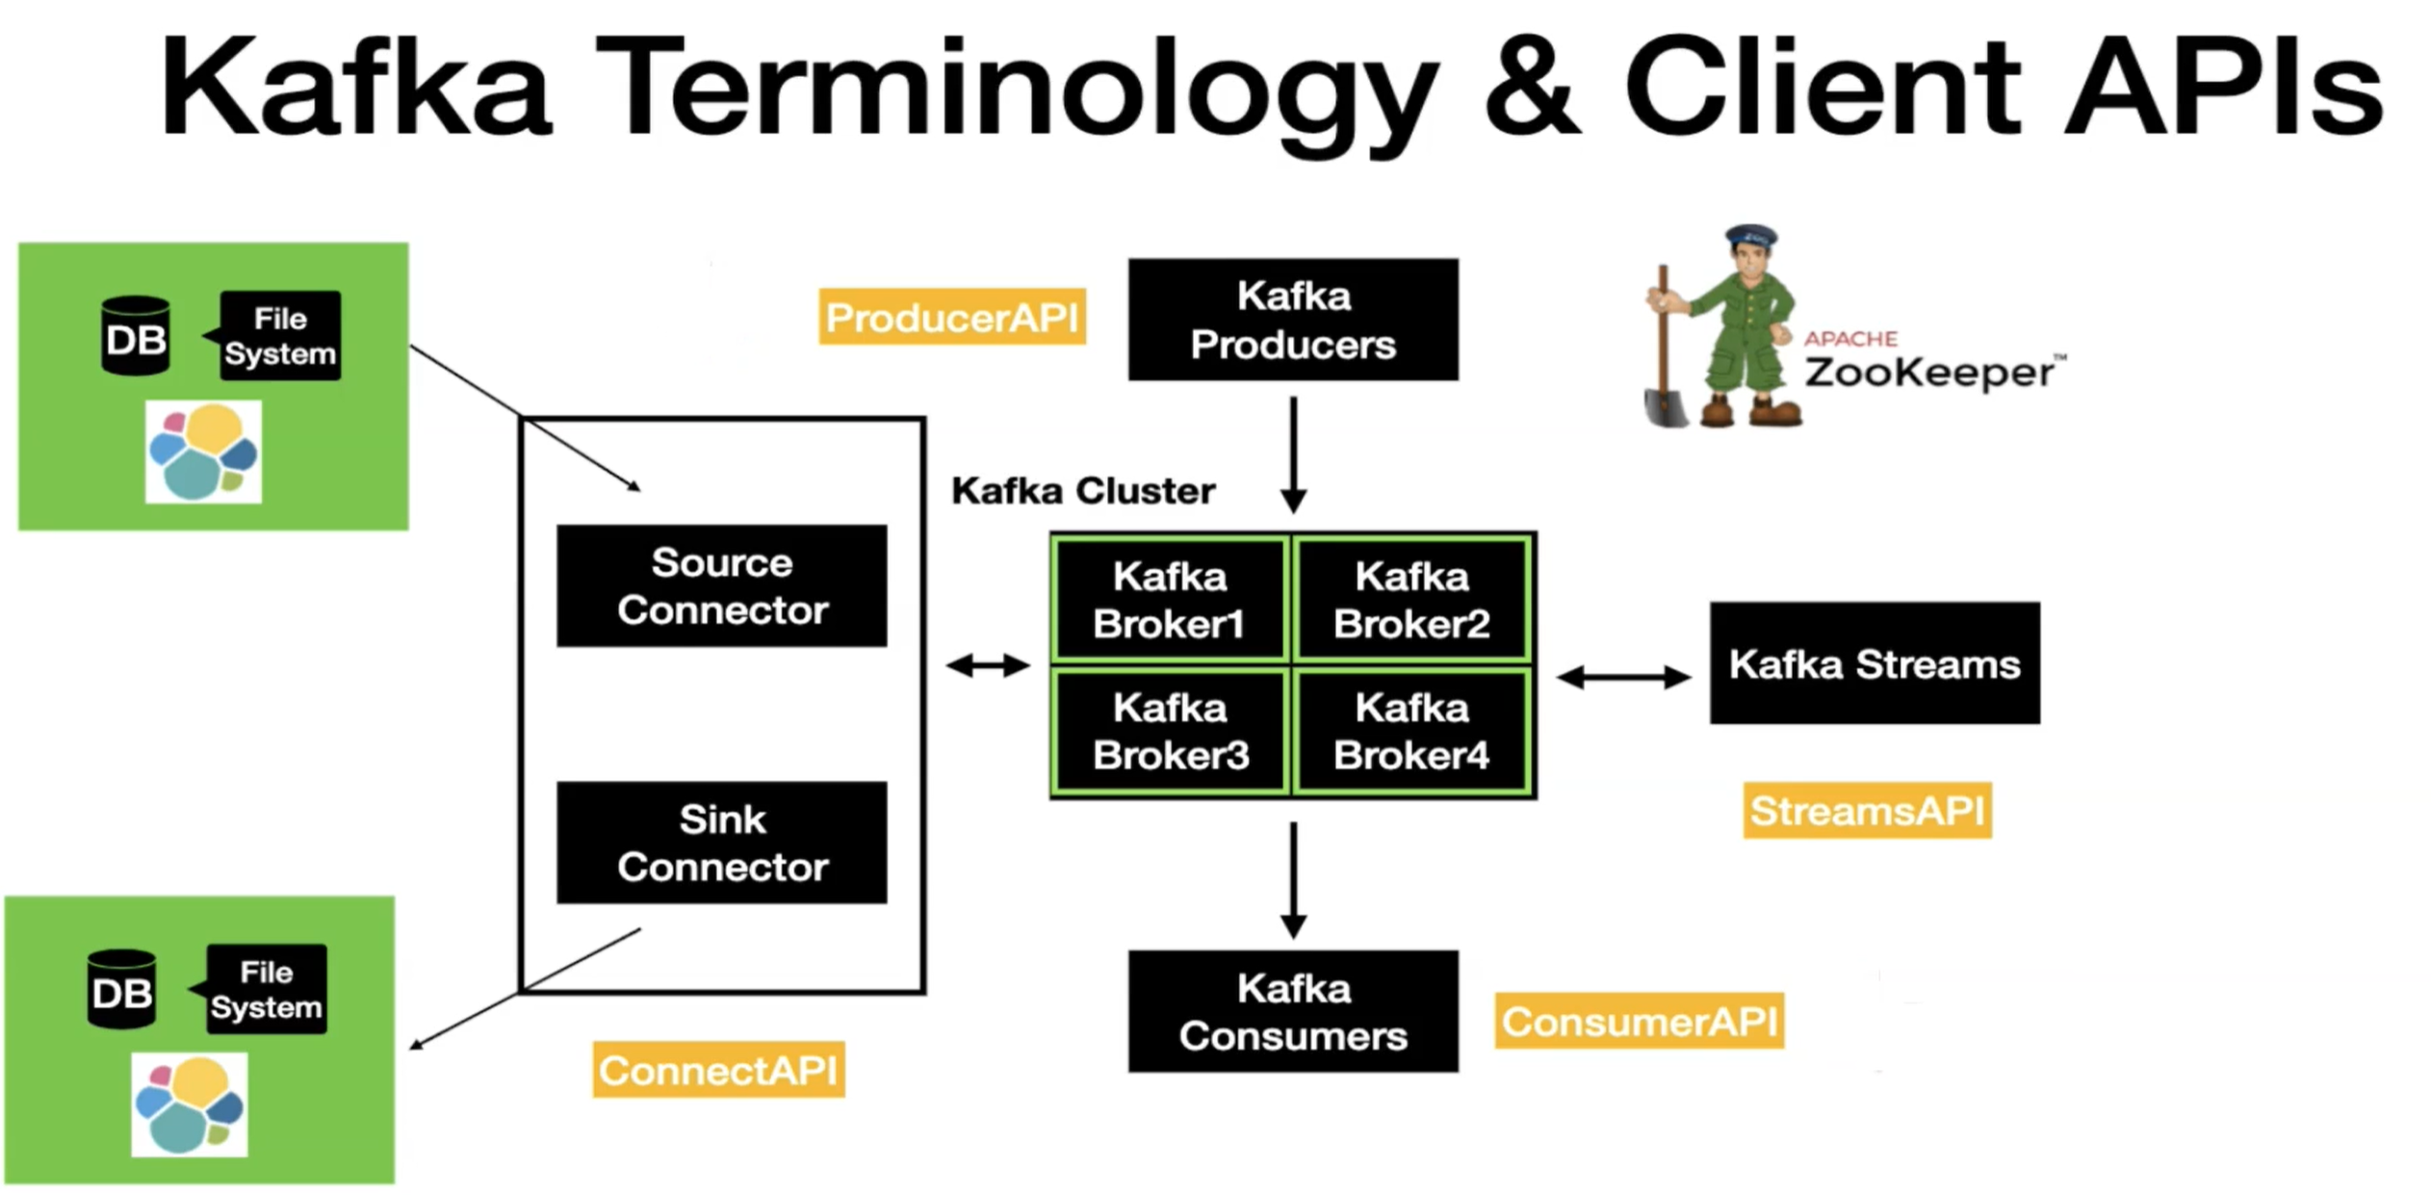
* Apache Zookeeper manage multiple Kafka broker and keep check health of Kafka cluster and Kafka broker
* Broker is what all Kafka client interact with.
* Kafka Producer(producer API) is way to write or produce data into Kafka
* Kafka consume (Consumer API) data from Kafka
* Kafka producer and consumers are basic client APIs through which we are interacting with Kafka.
* There is some advanced API with Kafka i.e. Kafka connect(connect API) which having mainly two connectors 1st Source connector and 2nd sink connector.
* Source connector is used for pulled data from external data source like databases, Elastic Seach, filesystem etc. into Kafka topic and opposite is done with this sink connector.
* With Kafka Connect, you can perform the data movement in and out of Kafka without writing a single line of code
* Stream API is basically used to take the data from Kafka and perform simple to complex transformations on it and put it back to Kafka.